STAKEHOLDER CASE STUDY
Reading a Positive Experiment Signal Without Overstating It
A holdout analysis where the assignment audit changes how confidently the uplift can be used.
DECISION IN ONE LINE
Treat the result as positive evidence, then confirm the randomization unit before rollout sizing.

852,197  cleaned event rows | +13.9%  brief-defined uplift | +5.5%  user-cohort sensitivity | 1,569  estimated extra conversions
Prepared by Phan Hoai Thu | Data Analyst / BI Analyst

Executive answer
Under the metric defined in the brief, treatment converted at 2.23% versus 1.95% for control, a +13.9% relative uplift with p = 3.42e-09. The effect is positive in all five cohorts. However, 26,426 users appear in both groups across months; the user-cohort sensitivity view estimates a smaller but still positive +5.5% uplift with p = 0.016. Confirm assignment logic before forecasting rollout impact.
BUSINESS QUESTION
The business needed to know whether showing Rokt advertisements increased conversion compared with a suppressed-ad holdout. A conventional uplift calculation was not enough: duplicate records, missing categories, repeated users, and unclear assignment grain could all change the interpretation.

What the evidence says

1. The primary KPI gives a clear positive signal
Treatment exceeds control by 0.272 percentage points. A simple control-rate counterfactual implies about 1,569 additional conversions across the treatment population.
Evidence trail: data/aggregated/headline_metrics.json and group_kpis.csv
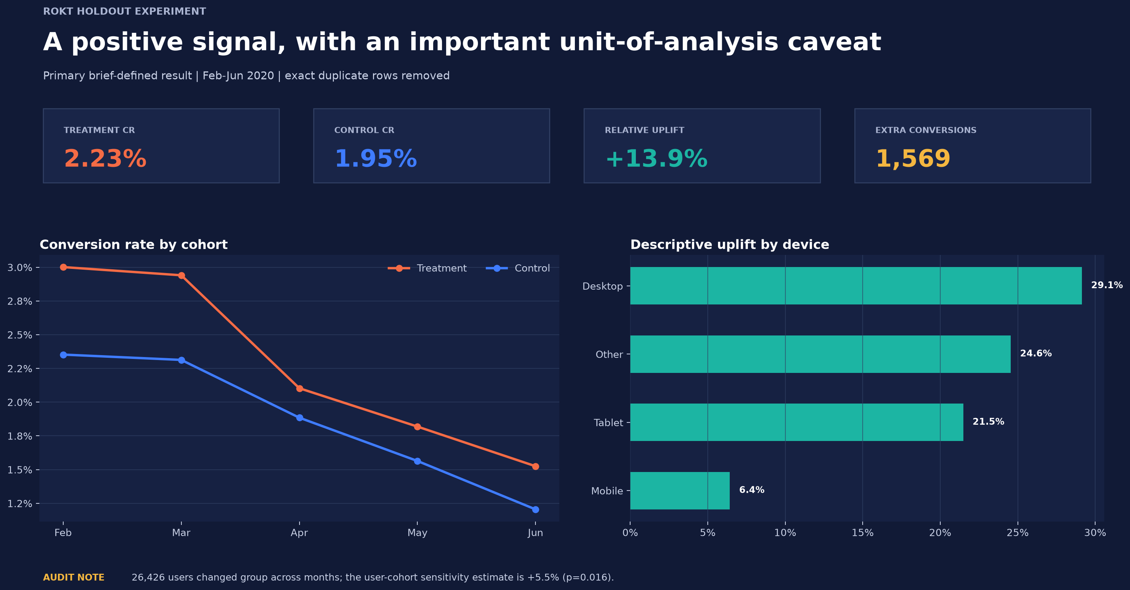
The decision view keeps the headline uplift and the unit-of-analysis caveat together.
Source evidence: data/aggregated/headline_metrics.json and group_kpis.csv

2. The direction is consistent, while baseline performance falls
Treatment conversion is higher in every monthly cohort, with descriptive uplift from 11.6% to 27.6%. Both treatment and control rates decline from February to June, so time effects deserve a separate investigation.
Evidence trail: data/aggregated/cohort_summary.csv
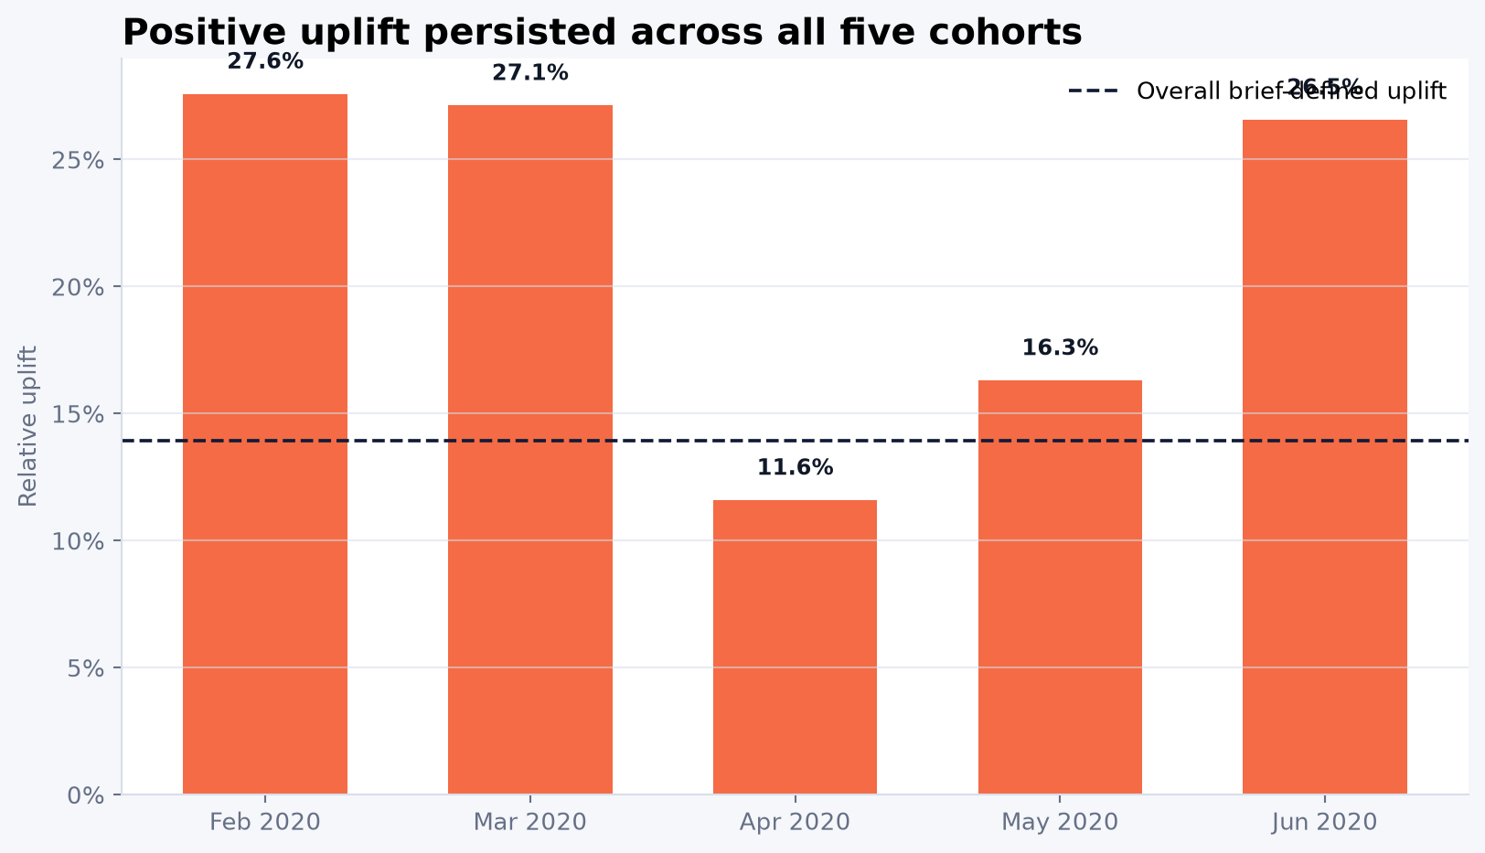
Treatment outperforms control in every cohort, even as overall conversion declines.
Source evidence: data/aggregated/cohort_summary.csv

3. The assignment audit narrows the confidence claim
Users can switch groups across months. Reporting unique-user, user-cohort, and session views side by side shows that the positive direction survives, but the headline magnitude is sensitive to the true randomization unit.
Evidence trail: data/aggregated/sensitivity_summary.csv
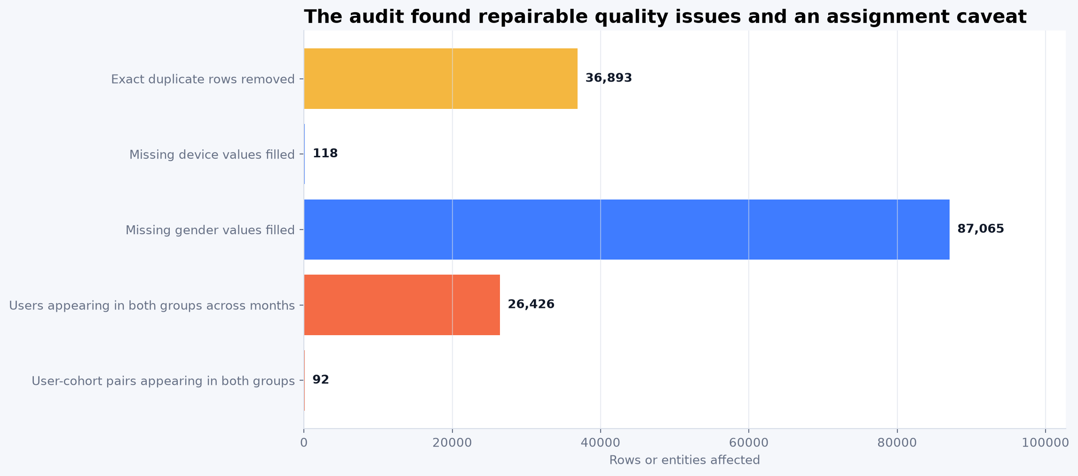
Cleaning and identity-overlap checks materially shape the interpretation.
Source evidence: data/aggregated/sensitivity_summary.csv

4. Desktop is a hypothesis, not a targeting rule
Desktop shows 29.1% descriptive uplift, but segment comparisons are exploratory and unadjusted for multiple testing. The result should define a follow-up experiment rather than a device rollout policy.
Evidence trail: data/aggregated/device_summary.csv

Recommended decision and operating plan
RECOMMENDATION
Treat the result as positive evidence, then confirm the randomization unit before rollout sizing.
- Confirm whether assignment was made by user, user-cohort, session, or event before using the estimate for rollout sizing.
- Investigate the conversion decline across cohorts and separate product/traffic mix from experiment effects.
- Run a preregistered device follow-up test if Desktop remains commercially important.
- Label the $239,887 estimate as illustrative conversion value, not verified Rokt revenue, profit, or causal financial impact.

Why the evidence is trustworthy
The technical design is summarized here only where it changes confidence in the business answer. The repository contains the complete code, notebooks, output tables, and implementation notes.
- Removed one invalid cohort row and 36,893 exact duplicate records before additive metrics.
- Normalized missing device and gender categories and audited cross-group identity overlap.
- Two-sided pooled two-proportion z-test with 95% confidence intervals for absolute lift and risk ratio.
- Primary brief-defined KPI reported alongside user-cohort and session sensitivity analyses.
- Public portfolio outputs contain aggregate data only; raw identifiers are excluded.

What this case does not prove
EVIDENCE BOUNDARY
A strong portfolio case separates a useful decision signal from claims the available data cannot support.
- The randomization unit is not explicit, and repeated users create cross-month dependence.
- Segment findings are exploratory and not adjusted for multiple comparisons.
- The equal-average-value counterfactual does not establish revenue or profit impact.

Evidence trail
Repository: Open the GitHub repository
Portfolio note: this document uses stakeholder-ready summaries and selected aggregate visuals. Technical implementation remains in the linked repository so a reviewer can audit the complete analytical chain.

