STAKEHOLDER CASE STUDY
Building an Executive Retail Operating Picture from Seven Disconnected Files
A tested warehouse, advanced analytics layer, and seven-page BI product for commercial and operating decisions.
DECISION IN ONE LINE
Manage to net sales and profit, attack the 25% leakage, and use customer and inventory segments for action.

$8.10M  net sales | $4.20M  net profit | 25.0%  sales leakage | 680,862  reconstructed sessions
Prepared by Phan Hoai Thu | Data Analyst / BI Analyst

Executive answer
The pipeline reconstructs 680,862 sessions from 2.42 million events, models 124,814 orders in a conformed warehouse, and produces a seven-page Power BI report. The commercial picture is $8.10M net sales and $4.20M net profit, but 25% of gross sales leaks through cancellations and returns. The customer base contains 19,550 Champions and 33,688 Hibernating customers, while $8.83M of unsold inventory cost signals a second operating priority.
BUSINESS QUESTION
Seven disconnected retail files could not answer how much the business earned after cancellations and returns, which channels converted, which customers were worth retaining, where delivery slowed, or where cash was trapped in stock. The project needed a trustworthy analytical foundation and a self-service decision product.

What the evidence says

1. Gross demand overstates realized performance
$10.80M gross sales becomes $8.10M net after $1.62M cancelled and $1.08M returned value. Executive reporting should manage to net sales and profit while keeping gross demand visible.
Evidence trail: docs/analysis_and_findings.md and mart commercial outputs
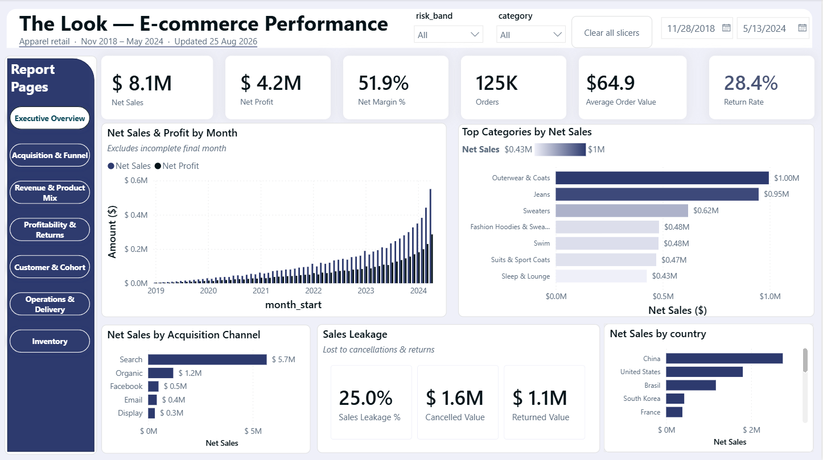
The executive view connects realized sales, profit, category mix, acquisition, and leakage.
Source evidence: docs/analysis_and_findings.md and mart commercial outputs

2. Lifecycle segments define audiences for a retention test
RFM segmentation identifies 19,550 Champions, 12,977 New/Developing customers, and 33,688 Hibernating customers. Champions hold $4.39M net sales, while Hibernating customers represent the largest reactivation pool.
Evidence trail: artifacts/advanced_metrics.json and customer_rfm_segment_profiles.csv
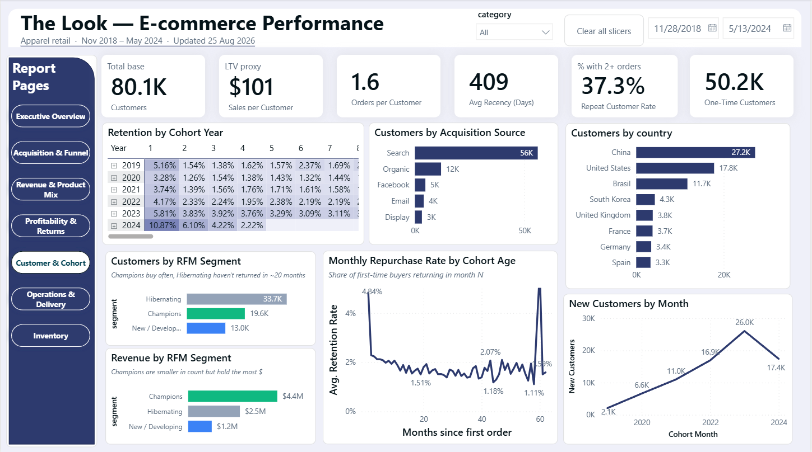
RFM segments turn customer history into retention and reactivation audiences.
Source evidence: artifacts/advanced_metrics.json and customer_rfm_segment_profiles.csv

3. Similar channel rates suggest a shared funnel hypothesis
Session conversion is about 26.6% and cart abandonment is 58.0%. Email and Adwords dominate volume, but conversion and abandonment rates are similar across channels, so the next test should focus on onsite/cart friction rather than assume a media-quality failure.
Evidence trail: docs/analysis_and_findings.md and mart funnel outputs
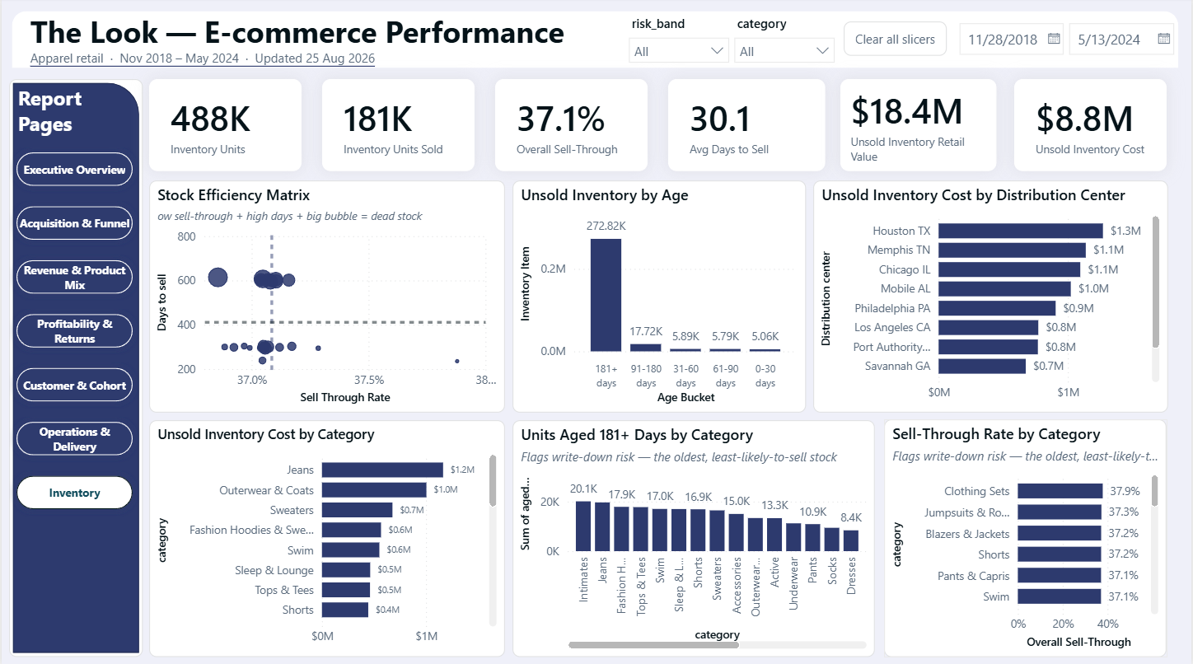
Aged units and unsold cost translate inventory data into working-capital priorities.
Source evidence: docs/analysis_and_findings.md and mart funnel outputs

4. Inventory and returns deserve operating attention
Observed return rate is 28.4%; unsold inventory cost is $8.83M; 272,822 units are aged 181+ days. These metrics connect merchandising, return root causes, and stock allocation to working-capital decisions.
Evidence trail: docs/analysis_and_findings.md and dashboard pages 4 and 7
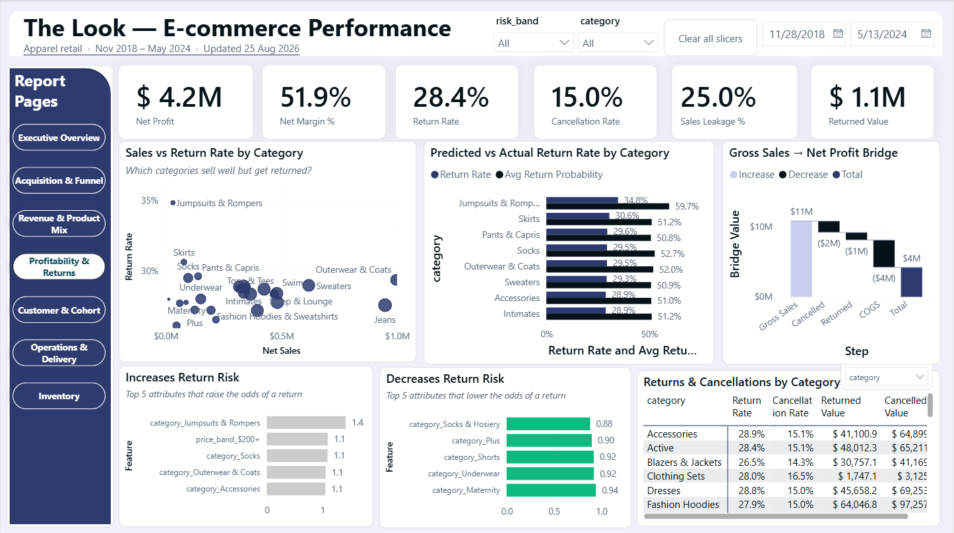
Returns and cancellations explain the bridge from gross sales to net profit.
Source evidence: docs/analysis_and_findings.md and dashboard pages 4 and 7

5. A weak model result is a decision, too
The return-propensity model achieves ROC-AUC 0.501 and top-decile lift 0.99x on a time holdout. The responsible recommendation is better feature and outcome logging, not deployment.
Evidence trail: artifacts/advanced_metrics.json

Recommended decision and operating plan
RECOMMENDATION
Manage to net sales and profit, attack the 25% leakage, and use customer and inventory segments for action.
- Use net sales, net profit, and leakage as the executive performance spine; exclude the partial May 2024 month from period comparisons.
- Protect Champions with loyalty treatment and test a low-cost win-back program for Hibernating customers.
- Investigate cancellation and return drivers in the highest-value categories and improve outcome/feature logging before revisiting return prediction.
- Review aged inventory and unsold cost by category and distribution center; connect write-down and transfer decisions to sell-through targets.
- Use funnel experiments to diagnose cart friction because channel conversion rates are broadly similar.

Why the evidence is trustworthy
The technical design is summarized here only where it changes confidence in the business answer. The repository contains the complete code, notebooks, output tables, and implementation notes.
- Seven declared source files loaded into a DuckDB raw-to-staging-to-core-to-mart-to-QA architecture.
- Sessions rebuilt from events inside SQL: 2,420,661 events reconcile exactly to 680,862 modeled sessions.
- Conformed star schema at declared grains, decision marts, DAX library, and seven-page Power BI design.
- The current saved validation report records PASS with no blocking errors; this editorial review did not rerun the pipeline.
- Advanced layer includes Gini concentration, RFM K-means, market-basket analysis, power planning, and a time-held return model.

What this case does not prove
EVIDENCE BOUNDARY
A strong portfolio case separates a useful decision signal from claims the available data cannot support.
- The dataset is synthetic; recommendations demonstrate analytical method, not real-company market evidence.
- No marketing spend, promotion field, product-level cart contents, or experiment assignment exists.
- 35,440 shipment-before-order item rows are excluded from lead-time metrics and coverage is disclosed.
- The weak return model should not be used as a production score.

Evidence trail
Repository: Open the GitHub repository
Interactive report: Open the published Power BI report
Portfolio note: this document uses stakeholder-ready summaries and selected aggregate visuals. Technical implementation remains in the linked repository so a reviewer can audit the complete analytical chain.

