STAKEHOLDER CASE STUDY
Turning Promotion Leakage into an Explainable Review Strategy
Rule-based risk prioritization that balances investigator workload with promotion-cost coverage.
DECISION IN ONE LINE
Run the medium-balanced rule in shadow mode and collect investigator outcomes before automation.

7.00bn  VND credited promo cost | 4.26%  review-priority users | 26.94%  cost linked to that group | 23.89%  cost covered by chosen rule
Prepared by Phan Hoai Thu | Data Analyst / BI Analyst

Executive answer
Of 86,170 scored users, 3,671 (4.26%) are associated with 26.94% of credited promotion cost, about 1.89bn VND. The medium-balanced rule flags 1,994 users (2.31% workload) and covers 23.89% of total credited campaign cost. Because there are no confirmed fraud labels, the correct decision is shadow-mode manual review, not automated blocking.
BUSINESS QUESTION
A cashback and voucher campaign can drive growth while concentrating budget among users with behaviors consistent with promotion extraction. The business question was which users should be reviewed first, why they were selected, and what share of exposed promotion cost a realistic review queue could cover.

What the evidence says

1. Budget concentration tells the team where to look first
Campaign CAMP_A contains 254,309 transactions and 7.00bn VND of credited cost. One anonymized promotion accounts for 74.02% of that cost, so monitoring should follow budget exposure rather than treat all 73 promotions equally.
Evidence trail: data/output/campaign_overview.csv and campaign_promotion_breakdown.csv
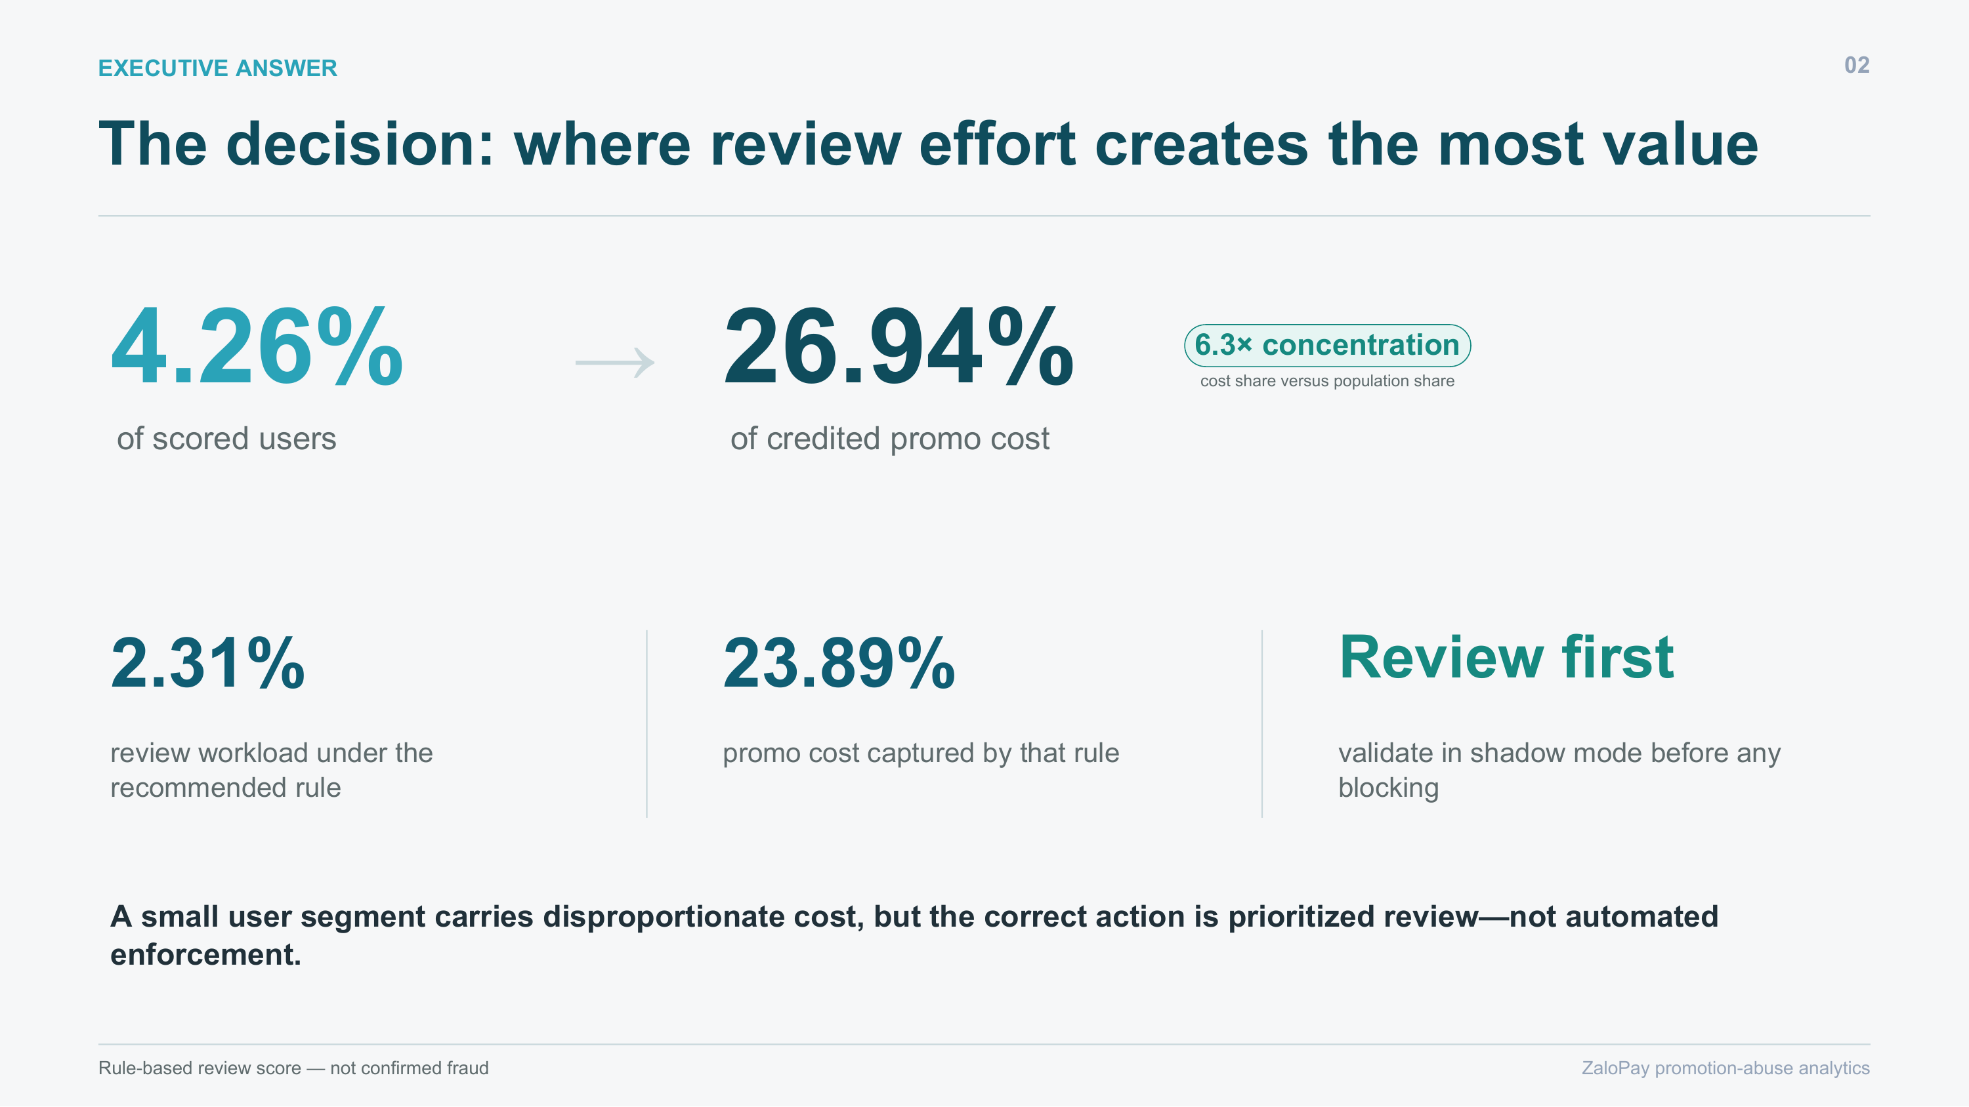
A 4.26% user segment is linked to 26.94% of credited promotion cost.
Source evidence: data/output/campaign_overview.csv and campaign_promotion_breakdown.csv

2. A small user segment carries a large cost share
The 4.26% review-priority population is linked to 26.94% of credited cost, a 6.3x concentration relative to its population share. The peak daily share reaches 40.7%.
Evidence trail: data/output/abuse_impact_summary.csv and campaign_daily_risk_summary.csv
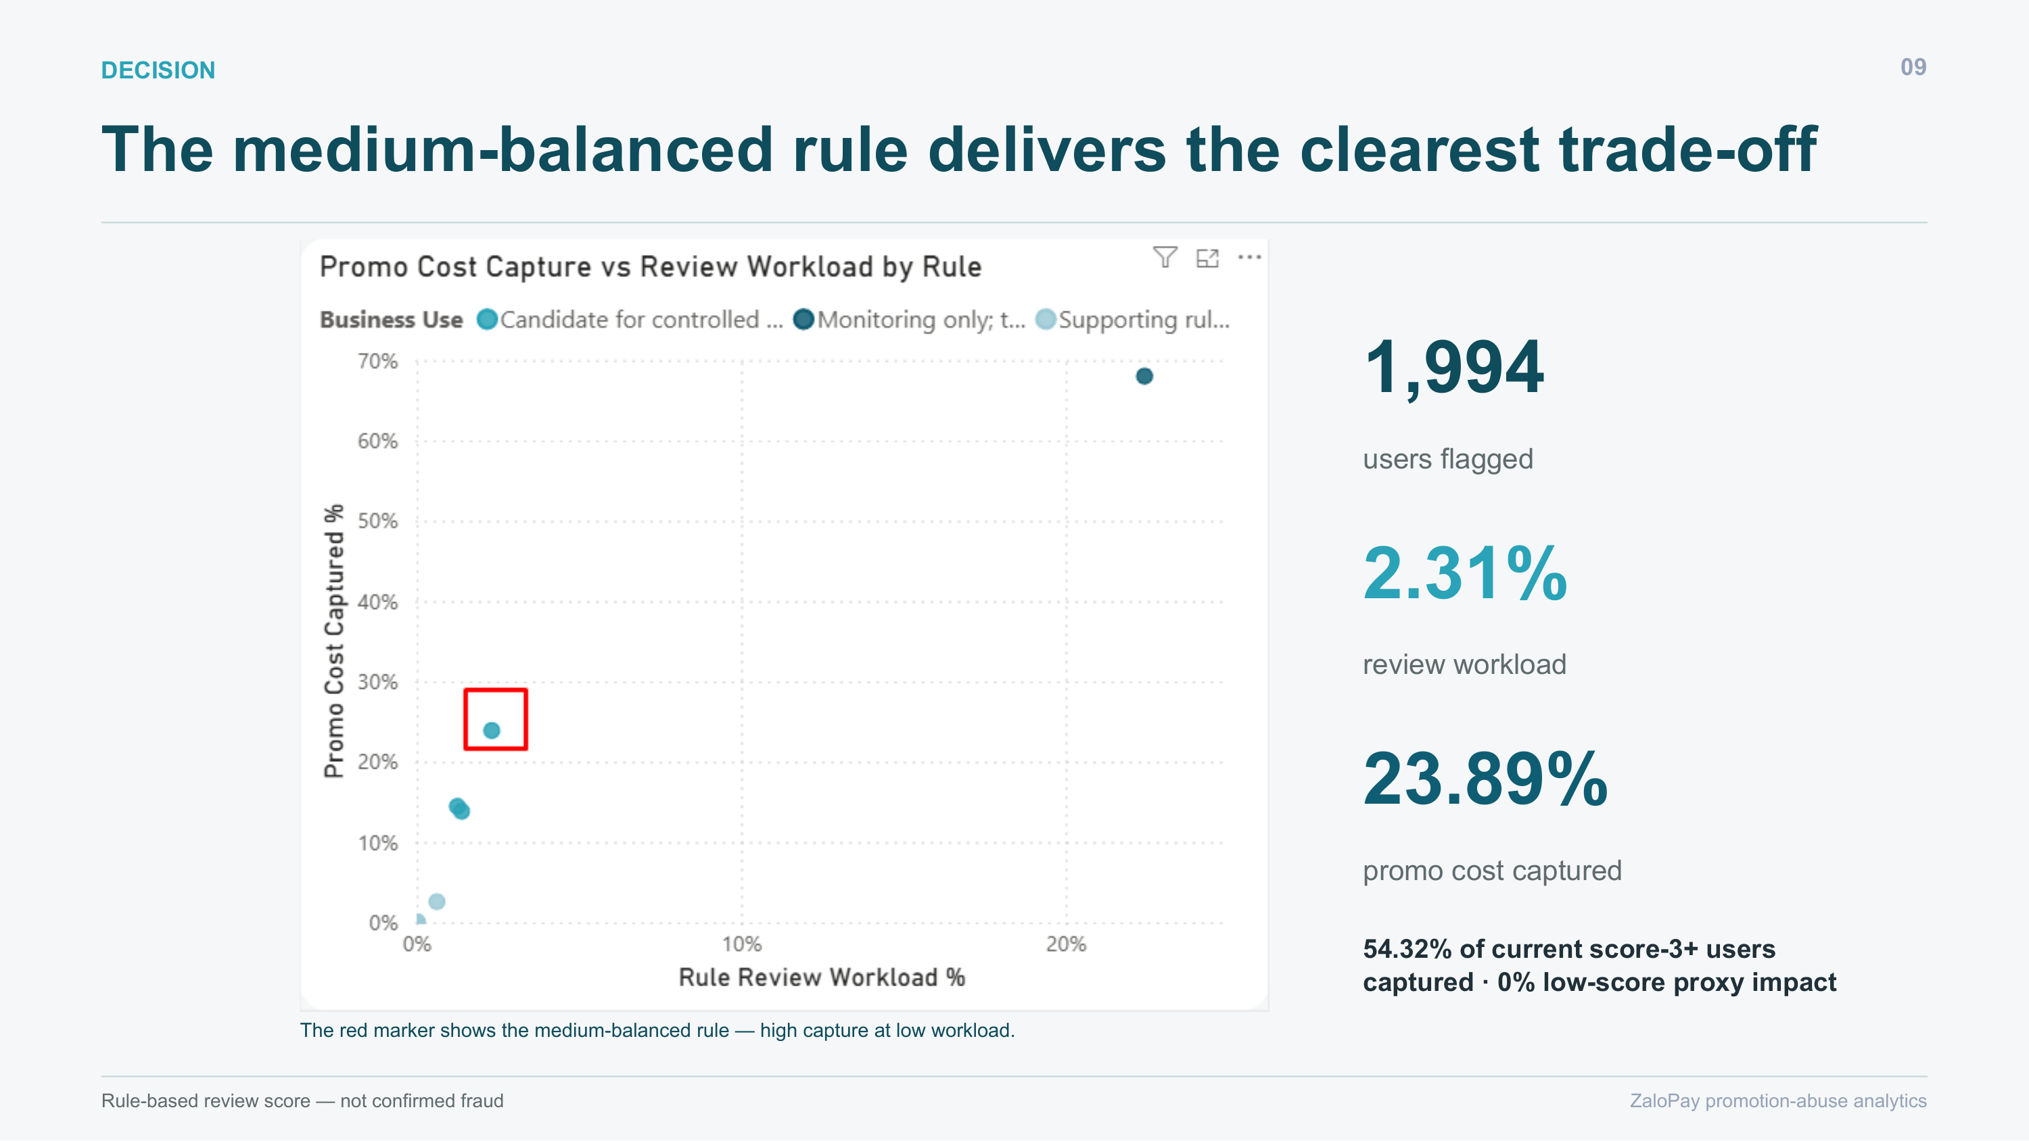
The chosen rule covers 23.89% of total credited campaign cost with a 2.31% review workload.
Source evidence: data/output/abuse_impact_summary.csv and campaign_daily_risk_summary.csv

3. Multi-signal logic is more defensible than a one-behavior ban
The score combines immediate discount redemption, credited discount, referrals, device sharing, IP sharing, and reciprocal transfer loops. Each flagged case receives a score, the signals that fired, and a readable reason.
Evidence trail: sql/07b_abuse_user_features_view.sql and sql/08_abuse_detection_rules_final.sql
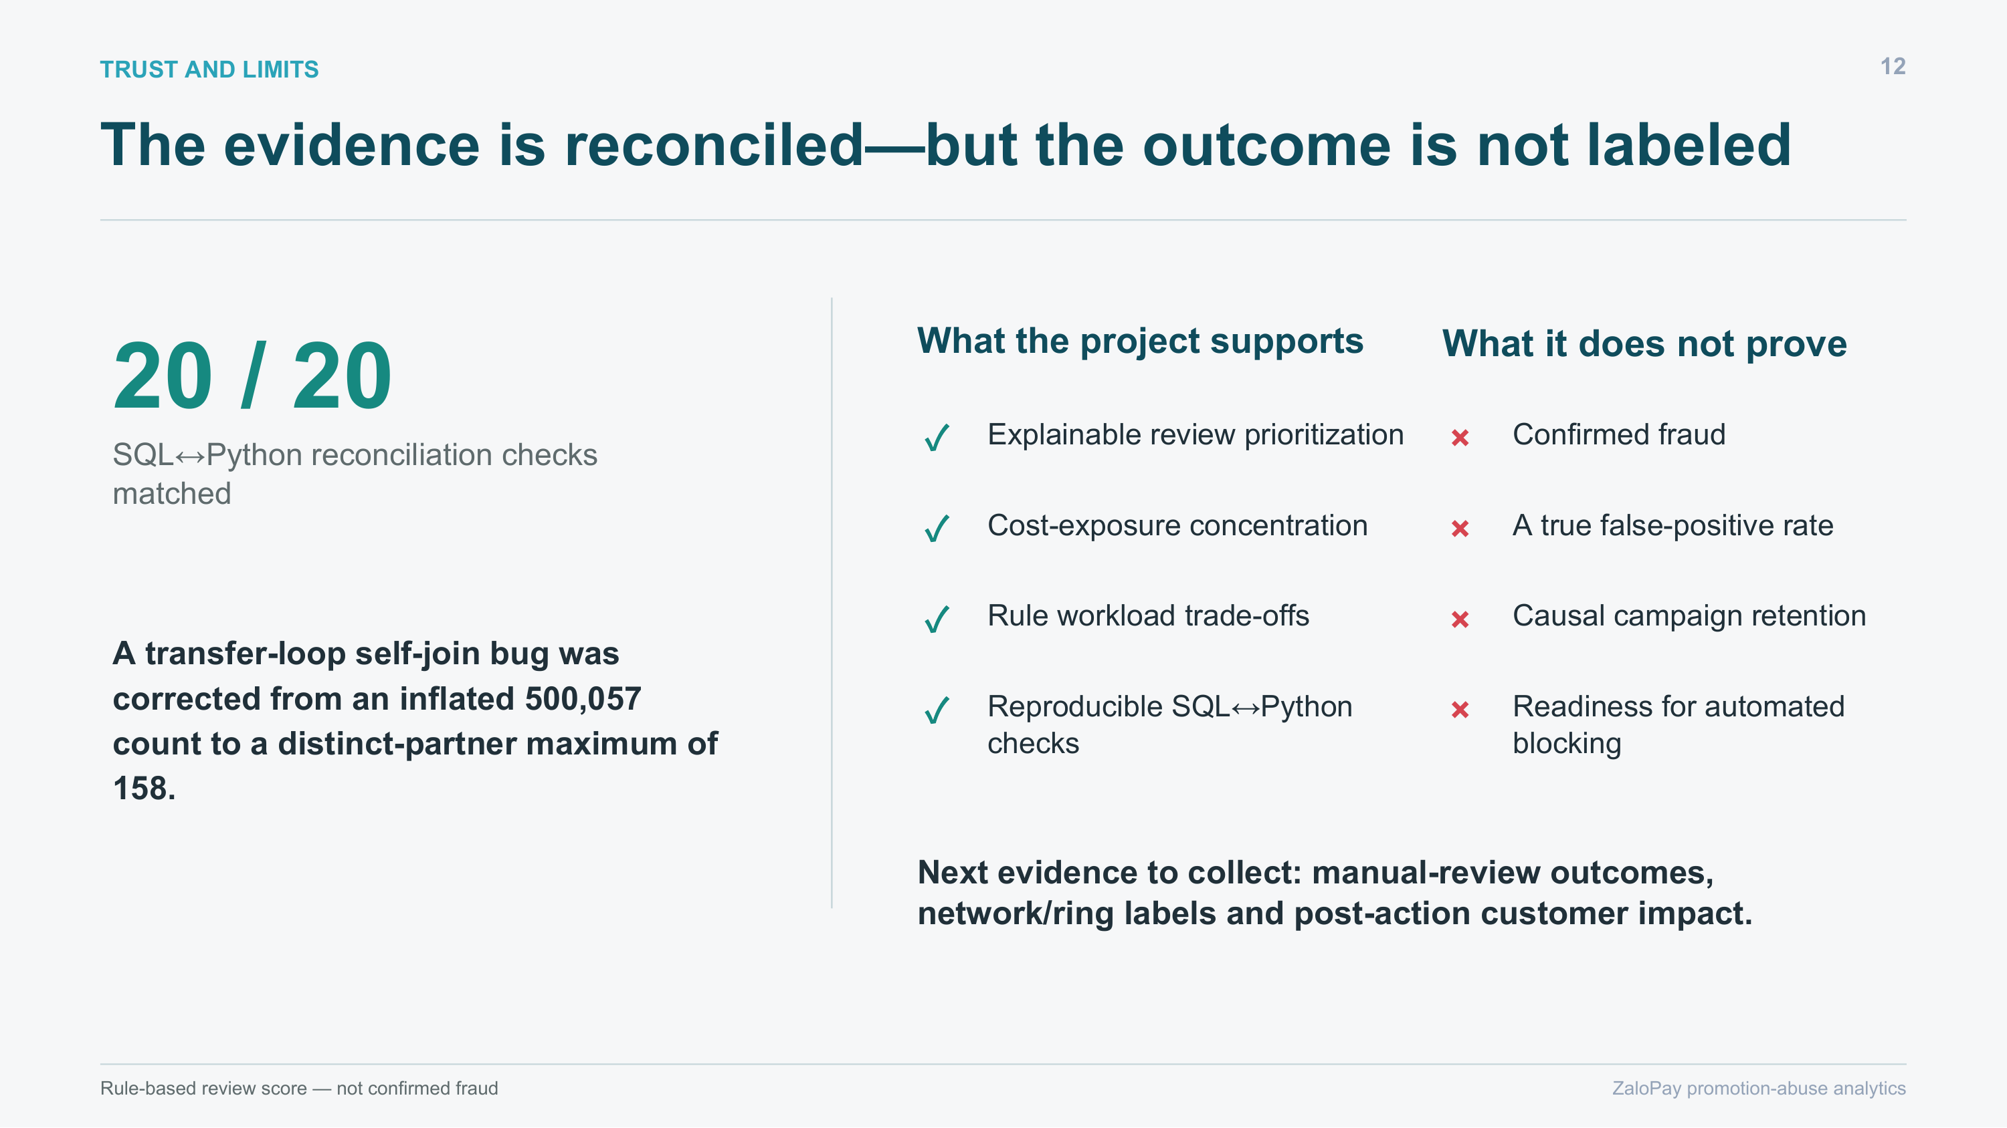
The pipeline reconciles, but unlabeled outcomes rule out automatic enforcement.
Source evidence: sql/07b_abuse_user_features_view.sql and sql/08_abuse_detection_rules_final.sql

4. The balanced rule creates the clearest workload trade-off
A broad rule captures 68.0% of cost but flags 22.4% of users and over-reaches. The recommended rule covers 23.89% of total credited campaign cost with a 2.31% review queue and zero low-score proxy impact.
Evidence trail: data/output/python_rule_simulation/python_business_rule_recommendations.csv

Recommended decision and operating plan
RECOMMENDATION
Run the medium-balanced rule in shadow mode and collect investigator outcomes before automation.
- Deploy the medium-balanced rule in shadow mode and route the queue to investigators.
- Prioritize the dominant promotion and merchants with the largest exposed credited cost.
- Keep the review-score disclaimer visible in the dashboard and operating procedure.
- Collect outcomes for flagged and unflagged samples, then measure precision, recall, workload, customer harm, and recovered value before any blocking test.

Why the evidence is trustworthy
The technical design is summarized here only where it changes confidence in the business answer. The repository contains the complete code, notebooks, output tables, and implementation notes.
- T-SQL performs trust checks, campaign selection, six-signal feature engineering, scoring, and BI exports.
- Python independently rebuilds the decision metrics, simulates seven rules, sweeps thresholds, and reconciles against SQL.
- All 20 published SQL-to-Python checks match, including suspicious-user count, cost share, and baseline rules.
- A transfer-loop cross-product bug was corrected from 500,057 apparent loops to a distinct-partner maximum of 158.
- A five-page Power BI report turns exposure, behavior, rule trade-offs, and caveats into a review workflow.

What this case does not prove
EVIDENCE BOUNDARY
A strong portfolio case separates a useful decision signal from claims the available data cannot support.
- No confirmed fraud or bot labels exist; suspicious means review priority only.
- The low-score impact metric is an internal-consistency proxy, not a measured false-positive rate.
- Retention is overall-payment context and does not prove campaign-attributed retention by risk group.

Evidence trail
Repository: Open the GitHub repository
Interactive report: Open the published Power BI report
Portfolio note: this document uses stakeholder-ready summaries and selected aggregate visuals. Technical implementation remains in the linked repository so a reviewer can audit the complete analytical chain.

